Business Interface

The EJB specification mandates that the enterprise bean class provide an implementation of all methods declared in the Remote or Local interface, but the bean cannot directly implement these interfaces.
How can inconsistencies between remote/local interface methods and the enterprise bean implementation be discovered at compile-time?
One of them most common errors experienced during the EJB development process is the lack of consistency between the business method definitions in the remote or local interfaces and implementations in the enterprise bean class. The EJB specification requires that the enterprise bean properly implement all the business method signatures defined in the remote/local interface, but does not provide for an automatic way to detect these problems at compile time. Many types of errors can arise from this decoupling of interface definition and implementation, including miss-typing of method names, parameter types, exceptions, inconsistent parameters, etc. As a result, these types of errors cannot be detected at compile time, the EJB developer must manually maintain consistency between interface definition and bean implementation.
The errors can only be detected when using your EJB server vendor’s proprietary post-compilation tool. These tools are typically used to take compiled java classes and test them for compliance to the EJB spec, before packaging and deploying. These post compilation tools are typically slow and arduous to use, and are less viable to use for incremental compilation practices that developers often use to catch errors early. The end result is that development errors are caught later on in the development process.
One solution would be to have the enterprise bean directly implement the remote or local interface in the bean class. This would enforce consistency between method definition and implementation, using any standard java compiler. Unfortunately, the EJB specification advises against this practice, and with good reason. The Remote interface extends javax.ejb.EjbObject interface, and the Local interface implements the javax.ejb.EJBLocalObject interface, as in figure X.1. These interfaces define extra methods (isIdentical, getPrimaryKey, remove, etc), which are meant to be implemented by the EJBObject and EJBLocalObject stubs, not the enterprise bean class.
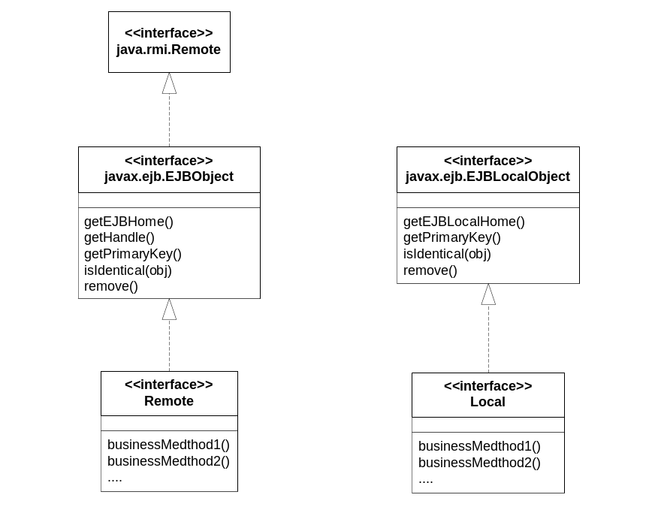
Figure X.1: EJBObject and EJBLocalObject Interfaces

In order to make your bean compile, you would have to clutter your enterprise bean class by writing dummy implementations of these extra methods. Furthermore, if the enterprise bean class directly implemented the Remote or Local interface, then the bean could be directly cast to one of these interfaces, allowing a developer to pass an instance of this to a client. This behaviour is not allowed by the EJB specification. To pass a reference to one-self, a bean needs should first get a reference to itself by calling getEJBObject or getEJBLocalObject off of the SessionContext or EntityContext interface.
EJB developers should not implement the Remote or Local interfaces directly in their enterprise bean class, but developers need a mechanism that would allow compile time confirmation of consistency between Remote/Local interface method definitions and implementations in the bean class.
Therefore,
Create a super interface called a Business Interface, which defines all business methods. Let both the remote/local interface and the enterprise bean class implement this interface, forcing compile-time consistency checks.
A Business Interface is a plain java interface that defines the method signatures for all the business methods an enterprise bean chooses to expose. The business interface is implemented by the Remote or Local interface, and the enterprise bean class, as in figure X.2. By creating this super-interface, errors in consistency between the method signature definitions in the Remote/Local interface and the enterprise bean class can be caught at compile time.
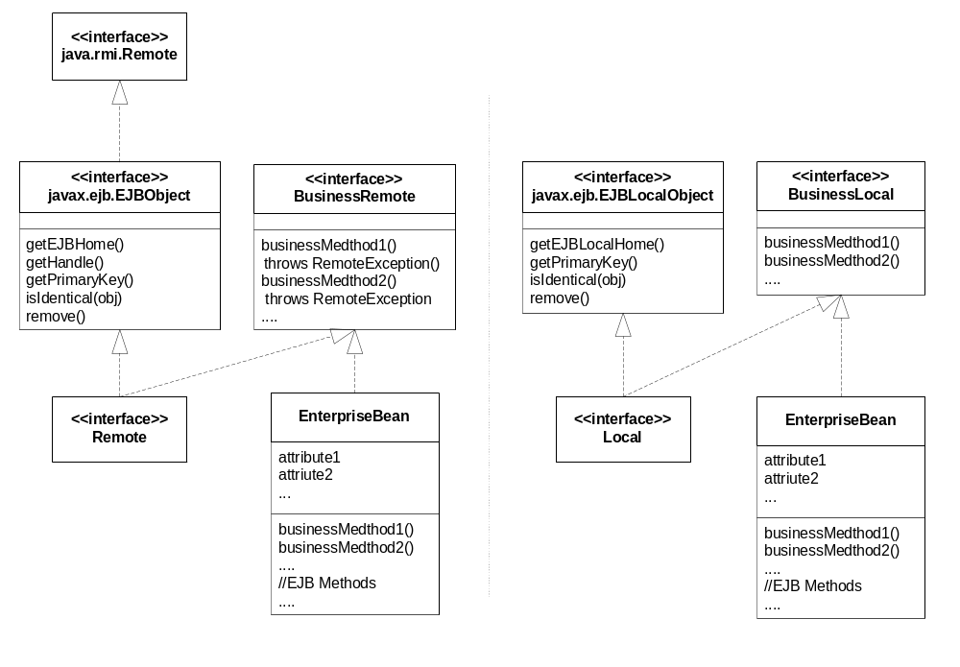
Figure X.2: Business Interface for Remote and Local Beans
The business interface does not implement javax.ejb.EjbObject or javax.ejb.EJBLocalObject, so the bean class developer does not have to implement dummy methods. Furthermore, the developer cannot cast the bean class directly to its Remote or Local interfaces, keeping the bean developer from passing this to its clients.
The Business Interface pattern differs slightly, depending on whether the enterprise bean exposes its business methods on the local interface or the remote interface. If exposing the Remote Interface, then all method signatures on the business interface need to throw java.rmi.RemoteException. Note that the method implementations in the enterprise bean class should not throw RemoteException, this has been deprecated by the EJB specification. Instead, business methods can throw EJBException from within the body of a method, without declaring it in the throws clause, since EJBException is a subclass of RuntimeException.
When using the Business Interface with a Local Interface, the Business Interface need not implement any other interface, and the business method signatures can be written without any special rules.
Business Interface is a common pattern in EJB development. It allows developers to catch common programming errors at compile time, ensuring consistency between business method definition and implementation. Business Interface pattern is used in the Client Side EJB Adapter pattern, to transparently create a proxy between clients and server EJBs.

